**Purpose of the Guide:**

**Due to shipping and variations in installation, the galvos may be misaligned. The goal of this guide is to help check and calibrate the galvos correctly. Firmware version 1.16 will not completely eliminate the optical distortion that may show on the edges of the build volume and we are still working on that. The rough galvo adjustments and the finer adjustments via the X/Y Size settings should help users to print dimensionally accurate parts in the center square area of the build plate.**

**\*This guide also works for Moai 200**

-

Before we start, make sure you have the protection glasses ready.

**NOTE: The X axis is front to back and the Y axis is left and right as you are looking at the printer from the front door.**

**1.** Remove Left and Right side panels and Built plate

**2. Set firmware settings for X/Y Size and X/Y Deviation to the default values: (critical)**

<http://wiki.peopoly.net/doku.php?id=moai:firmware>

**3.** Print the calibration-circle.pdf and cut it to the outer square and place it in the Vat.

(same as the setup steps)

<https://drive.google.com/open?id=0Bzke6lBHG_z5MkhwQjZ0bk5UaXM>

Note how the inside squares and circles are shifted. The side with the narrow spacing should be to the back of the Moai nearest to z-axis linear rail when the vat is installed.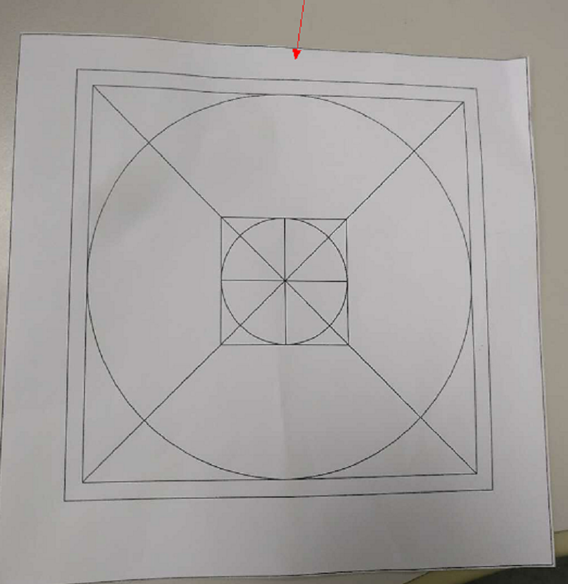

NOTE: **Make sure the Calibration Circle PDF is printed at 100% scale,** do not use the Fit to page option. The dimensions of the printed box should be 5-1/8" (130.18mm), and the largest circle should be 120mm diameter.

**4.** Insert the Vat with the printed calibration-circle in the Moai.

**Please wear your protection glasses for next step**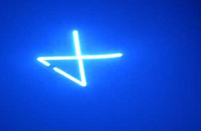

**5.** Centering with the laser. Download the center-cross gcode for Moai from [here](https://drive.google.com/open?id=1MnPFxxParUH_2cQgx4YL64S05QaAm0Qi). (Moai 200 [version here](https://drive.google.com/open?id=1mhBOITKgJT5DSrwv0f0InIW64FF_4-hN))It provides a crossing pattern that helps to match to the printed calibration circle’s center. The pattern looks like this:

If the center of the cross is too far away from the center of the circle, you can move the laser spot by using hex key (included in the kit) to loosen the clamping screws on galvo holder block. You can then turn the galvos by turning the motor part (where power cable is attached) to set its position while the laser is scanning the cross. Be very careful about it as a very small turn will affect the X/Y position greatly. **Do not touch the mirror part of the Galov.** Make sure both gavlo is pushed completely into the sockets. Y-Galvo may drop down a little when you loosen the screw. See below picture:

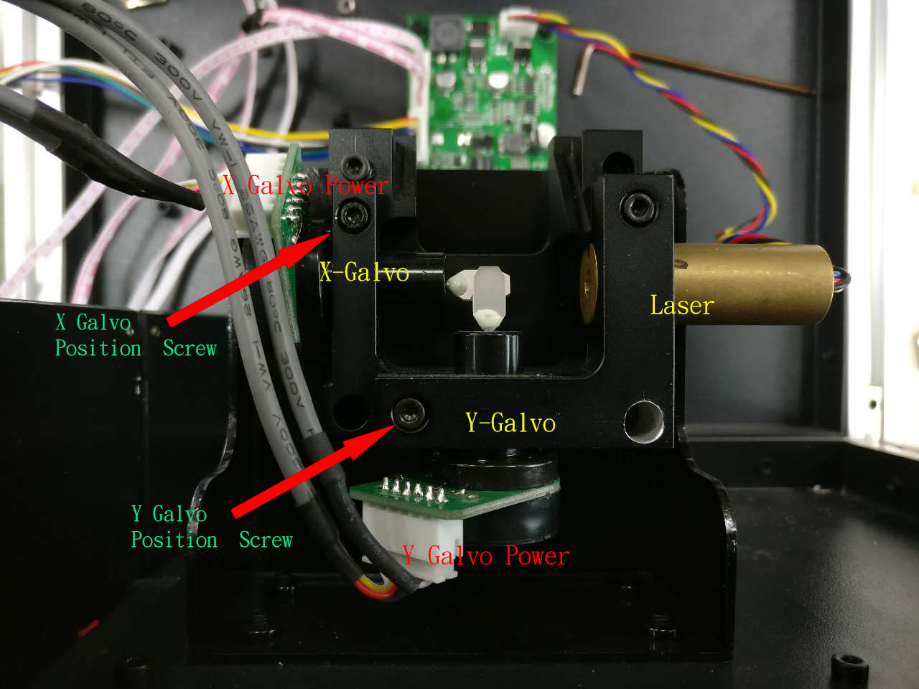

**6.** Download moai-adv-calib.zip from

<https://drive.google.com/open?id=0Bzke6lBHG_z5TEE0U3k0Szhabm8>

Moai 200 [version here](https://drive.google.com/open?id=1vLYipN84zp2M3vhEEM2oLn17jgd8iFE_)

Extract the moai-adv-calib.gcode inside the zip file and place it in the gcode directory of the sd card

**Please wear your protection glass for next step**

**DO NOT TOUCH TINY MIRRORS IN THE GALVO IN ANY CASE, SEE BELOW:**

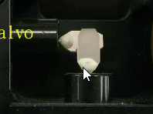

**7.** Print the moai-adv-calib.gcode.

The gcode will trace the outer larger circle of the printed calibration-circle 5 times before tracking the small circle for 15 times. It will then repeat.

While Moai is scanning the calibration circles, use a small slotted screwdriver (included in the kit) to adjust the potentiometer screw on galvo driver board so that the laser aligns to the printed circle. **(Be very careful, a very small turn will have a large effect on the size of the X/Y scanning)** Match the larger circle and then back to the smaller circle and vice versa until both matching closely. Once you have the scanning match the inner circle and outside the larger circle, you can stop by canceling the print. **You will likely not be able to get the outside circle and the inside circle to completely match, do not stress and focus on matching the outside circle and move on to next step.** 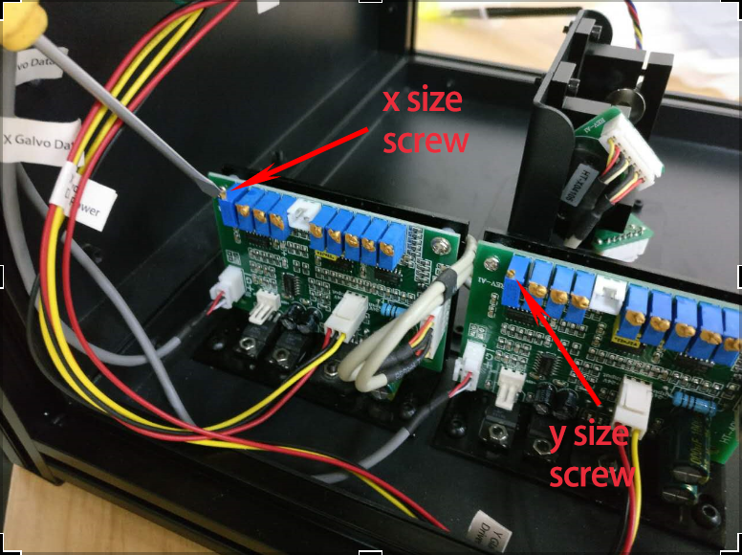

**For newer galvo**

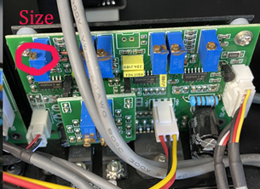

**8.** **Set Laser back to the previous level. 58 for Moai Model resin or other numbers for other resin** and then Print the 20mm cube to check calibration results. Do not modify the firmware setting:

<https://drive.google.com/open?id=0Bzke6lBHG_z5bEl2WjZNeHJHSUU>

**9.** If a minor adjustment is still needed, use Asura by Peopoly software to create custom calibration profile: <http://wiki.peopoly.net/doku.php?id=moai:asura>

**NOTE: The X-axis is front to back and the Y-axis is left and right as you are looking at the printer from the front door.**